Arduino interfacing with Microphone

**Arduino**

Arduino is an open-source electronics platform based on easy-to-use hardware and software. [Arduino boards](https://www.arduino.cc/en/Main/Products) are able to read inputs - light on a sensor, a finger on a button, or a Twitter message - and turn it into an output - activating a motor, turning on an LED, publishing something online. You can tell your board what to do by sending a set of instructions to the microcontroller on the board. To do so you use the [Arduino programming language](https://www.arduino.cc/en/Reference/HomePage) (based on [Wiring](http://wiring.org.co/)), and [the Arduino Software (IDE)](https://www.arduino.cc/en/Main/Software), based on [Processing](https://processing.org/).

Over the years Arduino has been the brain of thousands of projects, from everyday objects to complex scientific instruments. A worldwide community of makers - students, hobbyists, artists, programmers, and professionals - has gathered around this open-source platform, their contributions have added up to an incredible amount of [accessible knowledge](http://forum.arduino.cc/) that can be of great help to novices and experts alike.

**Why Arduino?**

Thanks to its simple and accessible user experience, Arduino has been used in thousands of different projects and applications. The Arduino software is easy-to-use for beginners, yet flexible enough for advanced users. It runs on Mac, Windows, and Linux. Teachers and students use it to build low cost scientific instruments, to prove chemistry and physics principles, or to get started with programming and robotics.

**Features**

· Inexpensive - Arduino boards are relatively inexpensive compared to other microcontroller platforms. The least expensive version of the Arduino module can be assembled by hand, and even the pre-assembled Arduino modules cost less than $50.

· Cross-platform - The Arduino Software (IDE) runs on Windows, Macintosh OSX, and Linux operating systems. Most microcontroller systems are limited to Windows.

· Simple, clear programming environment - The Arduino Software (IDE) is easy-to-use for beginners, yet flexible enough for advanced users to take advantage of as well. For teachers, it's conveniently based on the Processing programming environment, so students learning to program in that environment will be familiar with how the Arduino IDE works.

· Open source and extensible software - The Arduino software is published as open source tools, available for extension by experienced programmers.

· Open source and extensible hardware - The plans of the Arduino boards are published under a Creative Commons license, so experienced circuit designers can make their own version of the module, extending it and improving it.

**Architecture**

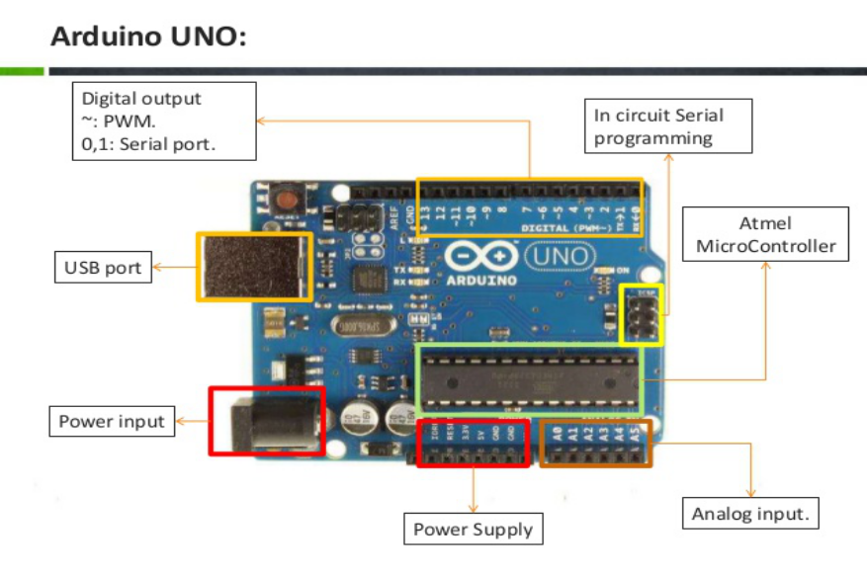

**Microphone**

Voice Record Module is base on ISD1820, which a multiple‐message record/playback device. It can offers true single‐chip voice recording, no‐volatile storage, and playback capability for 8 to 20 seconds. The sample is 3.2k and the total 20s for the Recorder.

**Features**

* Push‐button interface,
* playback can be edge or level activated
* Automatic power‐down mode
* On‐chip 8Ω speaker driver
* Signal 3V Power Supply
* Can be controlled both manually or by MCU
* Sample rate and duration changeable by replacing a single resistor
* Record up to 240 seconds of audio
* Dimensions: 37 x 54 mm

**Internal Circuit diagram**

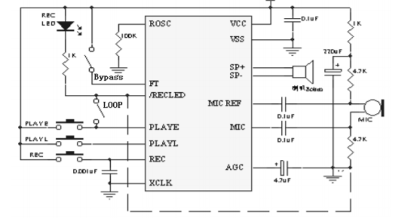

**Body**

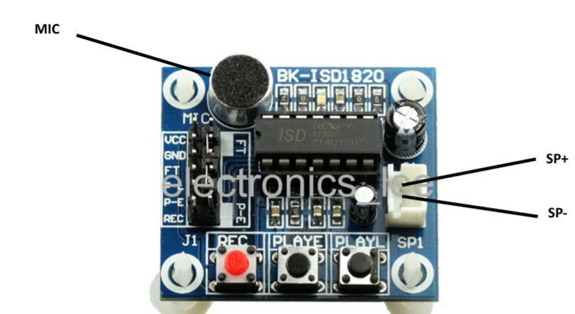

**Pin Description**

1. VCC– 3.3V power supply

2. GND– Power ground

3. REC – The REC input is an active‐HIGH record signal. The module starts recording whenever REC is HIGH. This pin must remain HIGH for the duration of the recording. REC takes precedence over either playback(PLAYL or PLAYE) signal.

4. PLAYE – Playback, Edge‐activated: When a HIGH‐going transition is detected on continues until an End‐of‐Message (EOM) marker is encountered or the end of the memory space is reached.

5. PLAYL – Playback, Level‐activated, when this input pin level transits for LOW to HIGH, a playback cycle is initiated.

6. Speaker Outputs – The SP+ and SP‐ pins provide direct drive for loudspeakers with impedances as low as 8Ω.

7. MIC – Microphone Input, the microphone input transfers its signals to the on‐chip preamplifier.

8. FT – Feed Through: This mode enable the Microphone to drive the speaker directly.

9. P‐E – Play the records endlessly.

**Operating instructions**

1. Push REC button then the RECLED will light and keep it pushed until record end.
2. Release the REC button.
3. Select Playback mode: PLAYE, just need push one time, and will playback all of the record or power down; PLAYL, you need always push this button until you want to stop playback record or end ; When short P‐E jumper the record will playback time a time until jumper off or power down.
4. FT mode, when short FT jumper, that means all of you speak to MIC will direct playback to Speaker.